July 5th , 2020
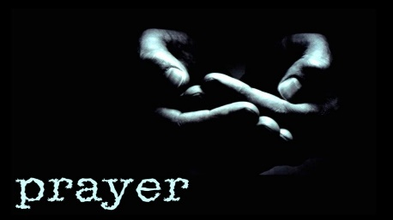

~Our country, President
Trump, Firemen, policemen & leaders
~Cate Clark- health
~John Weber
~Cody Hoelscher
~Connie Thoenen & Family
~Michelle Kliethermes’ brother-stage 4 lung cancer
~Kurt Stockman – cancer
~Rosalie (friend of Suetta Martin) – breast cancer
~Billie Probst – health
~Cami Fick – colorectal cancer
~Jerry Bunch
~Debbie Scheulen
~Terry Bouis – cancer
~Brenda Strope – health
~Tim and Irene Hollandsworth- relief from pain
~Irene Hollandsworth’s brother Richard Leiweke- healing
~Mark Greggor – stage 4 melanoma, spread to liver, bones and possibly bladder
~Becky Schlemper- pray doctors can find the cause of her sickness.
~Megan Reichart’s Mother (Rita Kelsey) – health
~Sara Wands – Multiple serious health problems
~Tanya Binggeli – health
~Andy Meuber - blood cancer
~ Everyone affected by the COVID – 19
~Karla Bridges friend Chris – diagnosed with leukemia
~Julie Wyss – strength to be able to walk
~Lauren Gann – pregnancy
~Kathy Hogan’s father & his leg issues
~Amy Mitchel – Pray for baby Lycas
~Linda Branson – granddaughters mom Jessica has a blood clot in right leg
~Sue Gelven’s friend Robert Baker - prostate cancer
~Megan Pritchard’s Aunt Sheila - recovering from bypass and infection after surgery
~Mary Bowen’s Friends Tom and Roger cancer
~Christy Warren’s cousin Roger – lung cancer
~Sue Gelven’s cousin Bill White – Parkinson’s getting much worse
~Christy Warren’s friend Susie – in an accident.
~Hoelscher Family – Pedro’s Aunt passed
~Mackenzie Branson – moved out of state
~Julie Wyss’ Sisters – health
~Our Church
~ Jeff and his family
~ Roger Rudd – heart bypass
~ Jay Spillman
~Lily Smith (Bonnie Elrod’s 20 mos. old granddaughter) – surgery to correct hip dysplasia
~Mitchell Family
~Robert Niekamp’s family

